Mr. Austin Booth 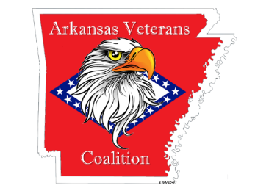
Director
Arkansas Game & Fish Commission
2 Natural Resources Drive
Little Rock, AR 72205 ?????, 2022

Director Booth:

The Arkansas State Veterans Coalition (“AVC”) is a non-partisan, not-for-profit organization comprised of Arkansas affiliates of nationally chartered/recognized veterans, military, uniformed services, and veterans service organizations, as well as similar local not-for-profit organizations with common goals. They work in joint pursuit to represent issues affecting the 197,000+ Arkansas Veterans and their families.
On our Friday, July 15, 2022, meeting the AVC Members unanimous voted to approve the enclosed Resolution.

In congruence with the expressed will of the AVC Membership’s will, I submit this letter and enclosed Resolution respectfully requesting the Commissioners recognize the service and sacrifice of the Arkansas’ Veterans who have honorably served our nation and the members of Gold Star Families who have had immediate family members Killed In Action:

- Special Hunting Season for Honorably Discharged Veterans

- A Lottery Hunt for Disabled Veterans

- License fee reduction for Combat Wounded (Purple Heart Recipients) with Permanent

- Immediate members of Gold Star Families (Father, Mother, Son, and Daughter of a KIA Veteran) be offered free Lifetime Deer Hunting and Fishing Licenses, to include Trout Tags.

The Officers of the AVC are at your and the Commissioners’ disposal to answer questions, provide testimony, or other information that is needed in support of the AVC’s request.

In advance of your consideration,

Respectfully,

